**LAB- 10 (program)**

**PROGRAM 10:- COLLEGE DATABASE**

**Consider the schema for College Database:**

**STUDENT(USN, SName, Address, Phone, Gender)**

**SEMSEC(SSID, Sem, Sec)**

**CLASS(USN, SSID)**

**SUBJECT(Subcode, Title, Sem, Credits)**

**MARKS(USN, Subcode, SSID, Test1, Test2, Test3, FinalIA)**

**i.List all the student details studying in fourth semester ‘C’ section.**

**ii. Compute the total number of male and female students in each semester and in each section.**

**iii. Create a view of Test1 marks of student USN ‘22’ in all subjects.**

**iv. Calculate the FinalIA (average of best two test marks) and update the corresponding table for all students.**

**v. Categorize students based on the following criterion: If FinalIA = 17 to 20 then CAT = ‘Outstanding’ If FinalIA = 12 to 16 then CAT = ‘Average’ If FinalIA< 12 then CAT = ‘Weak’ Give these details only for 8th semester A, B, and C section students.**

**Create table:-**

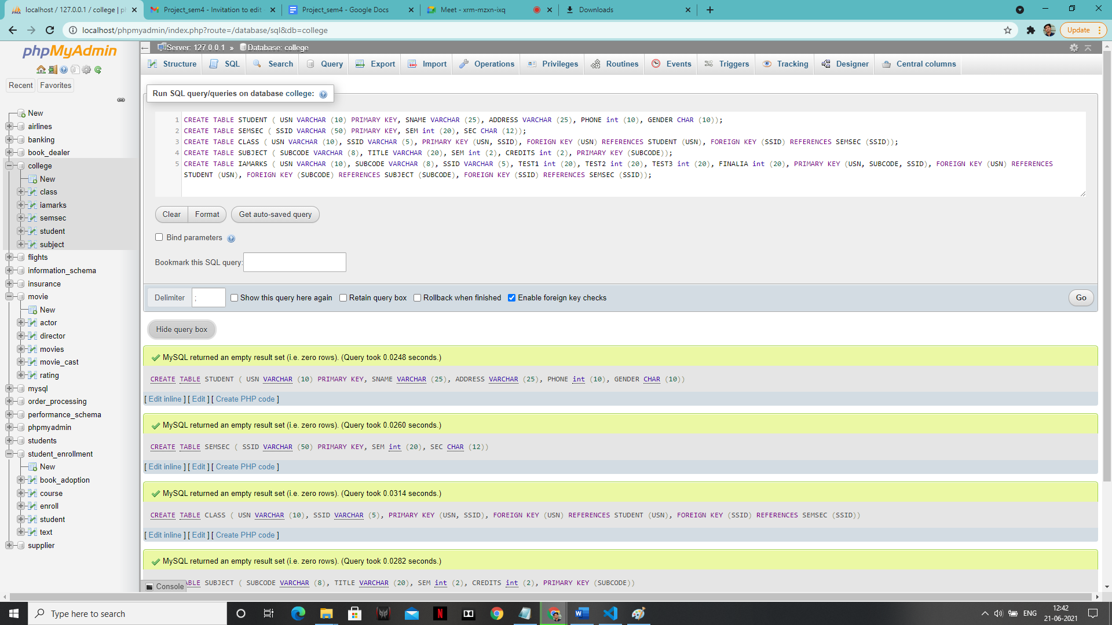

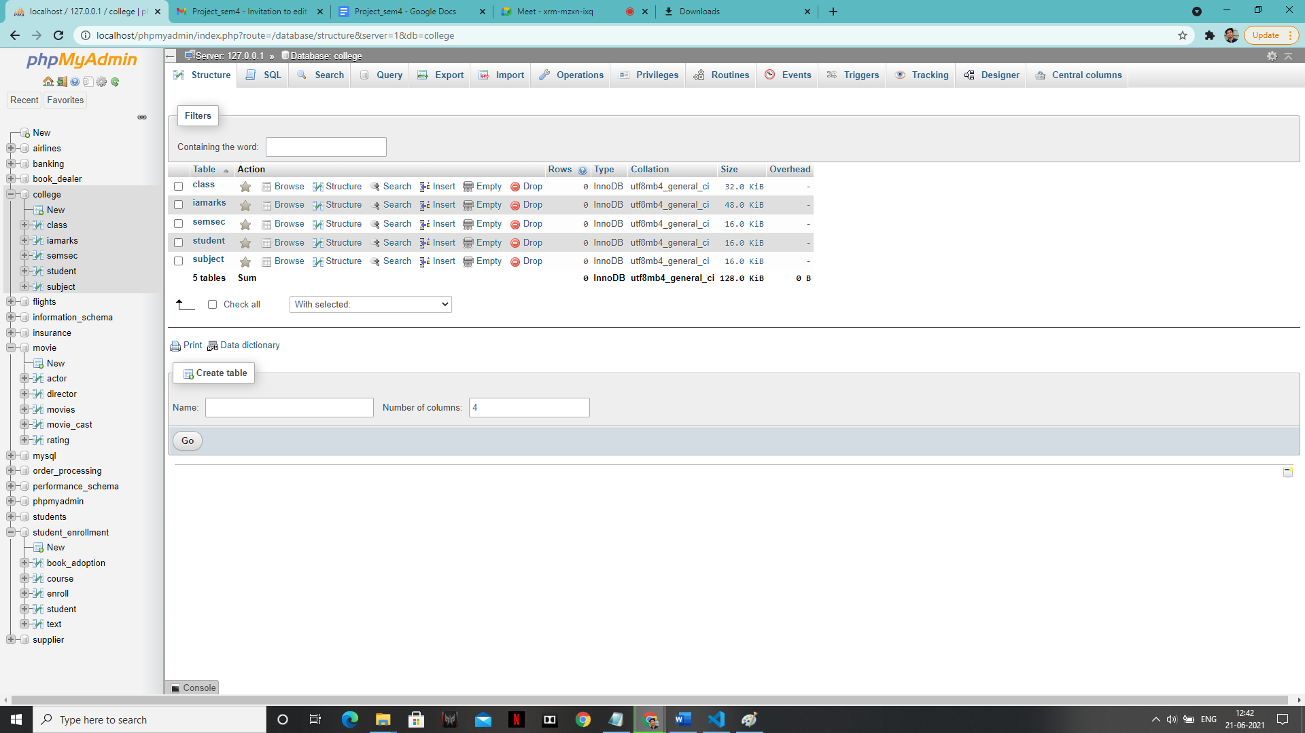

1. **Enter tuples for each relation.**

**‘STUDENT’ table:**

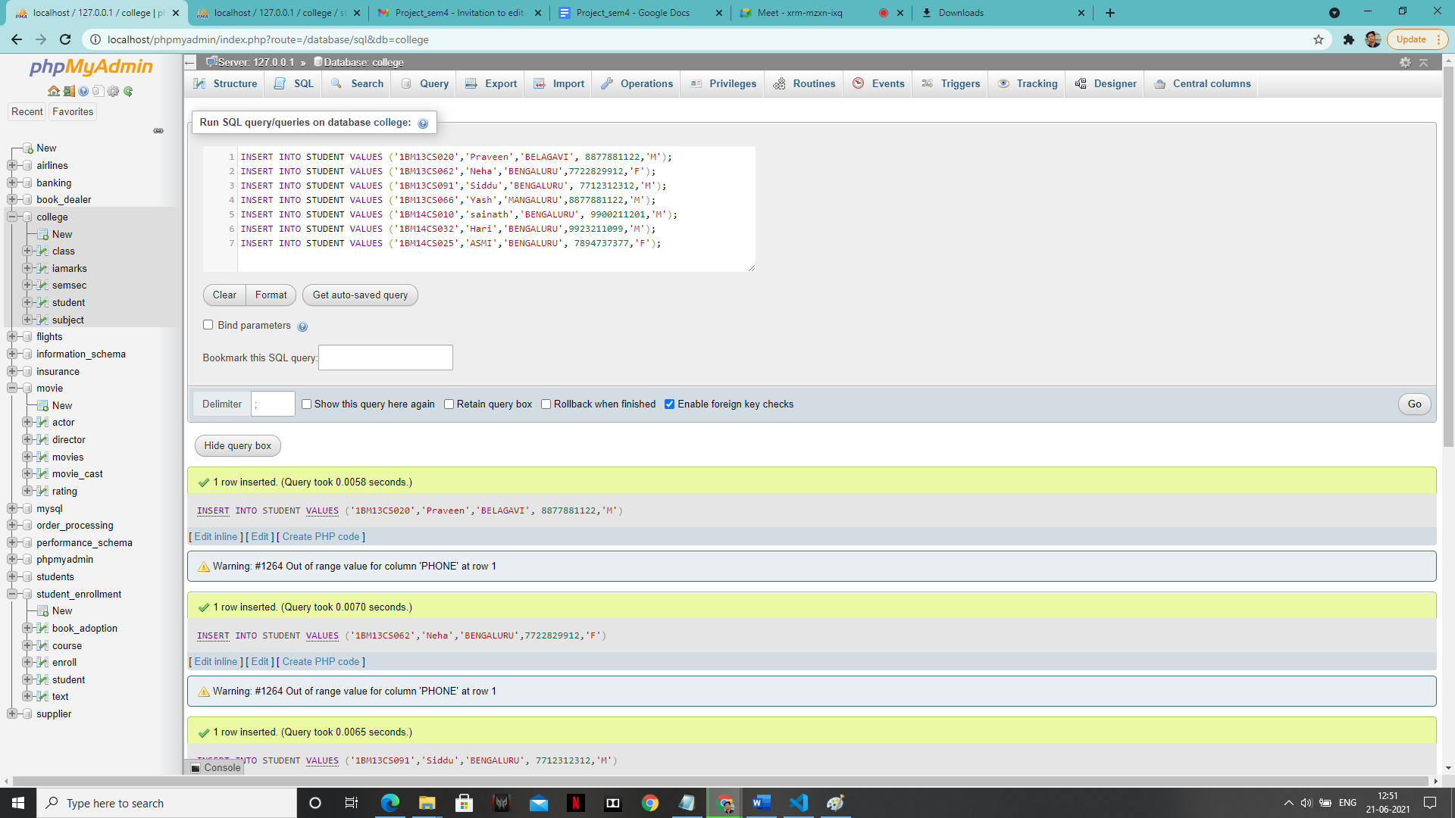

**‘Class’ table:**

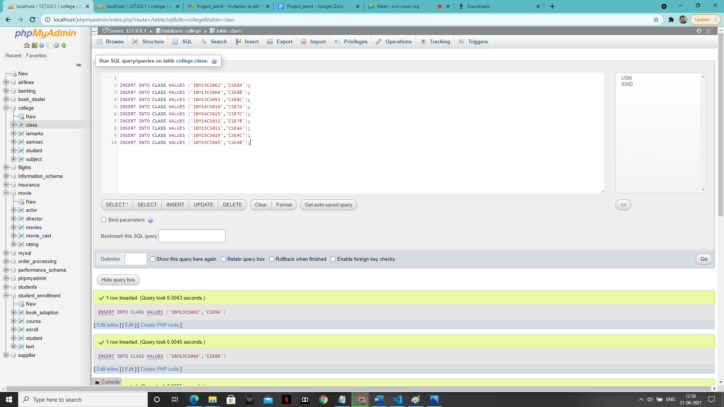

**‘Marks’ table:**

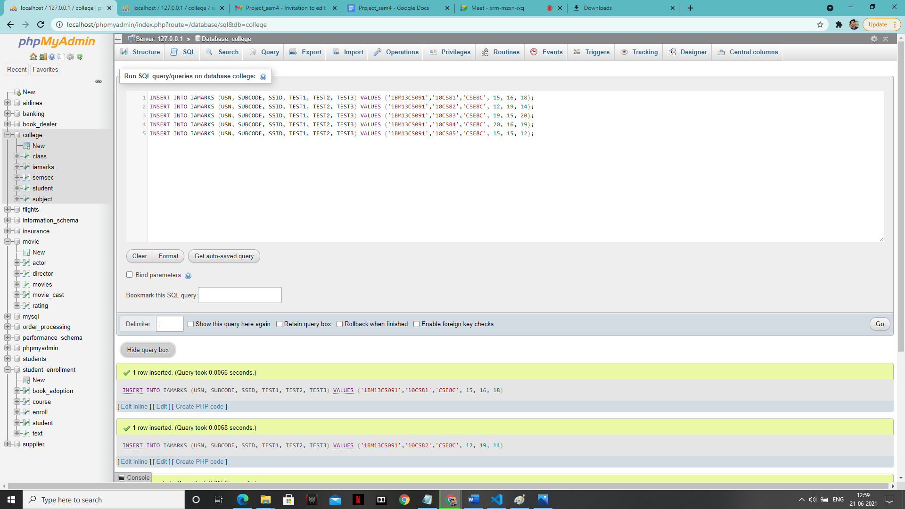

**‘semsec’ value: -**

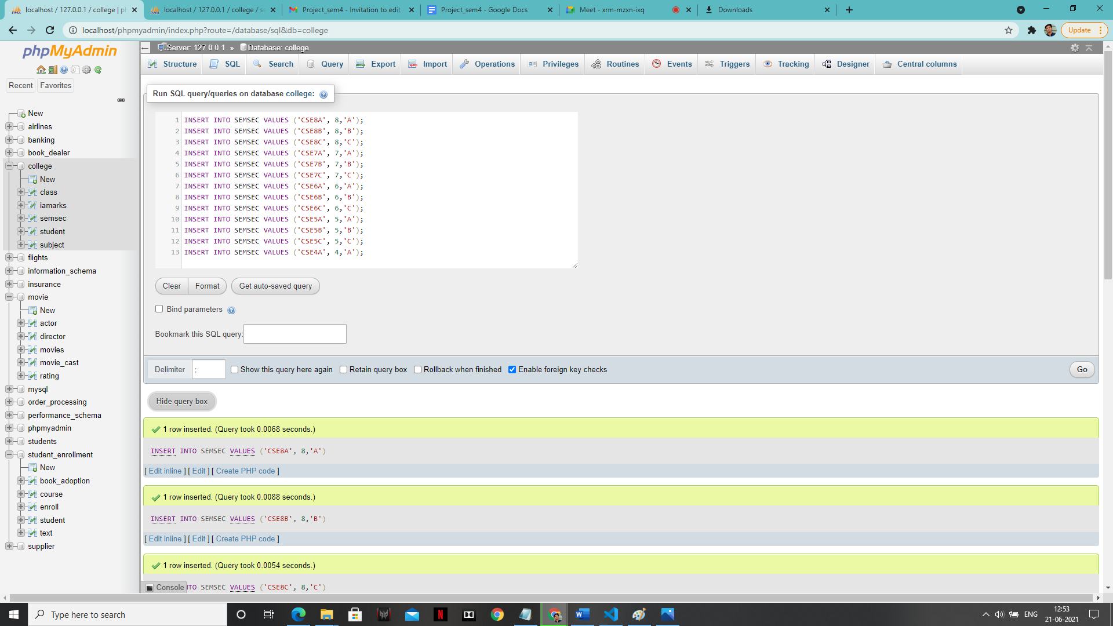

**‘subject’ table:**

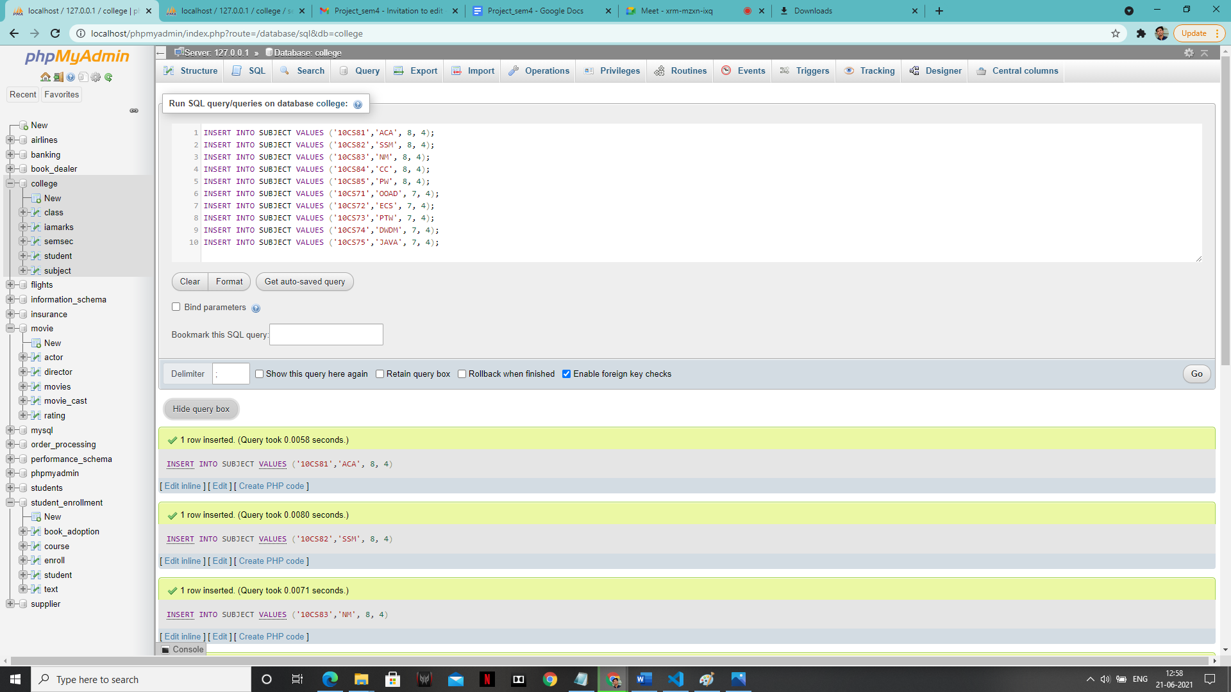

**SOLUTION**

**1:-**

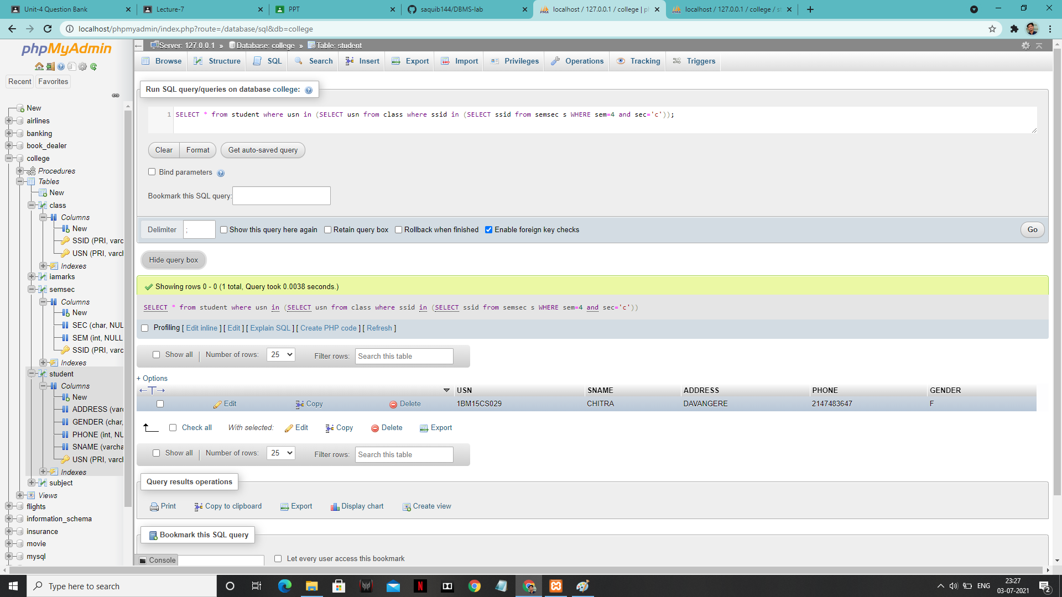

**2:-**

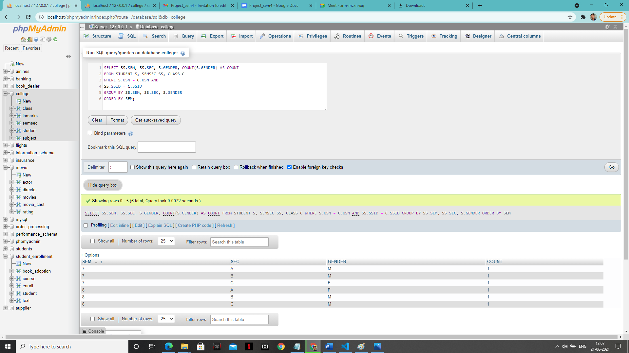

**3:-**

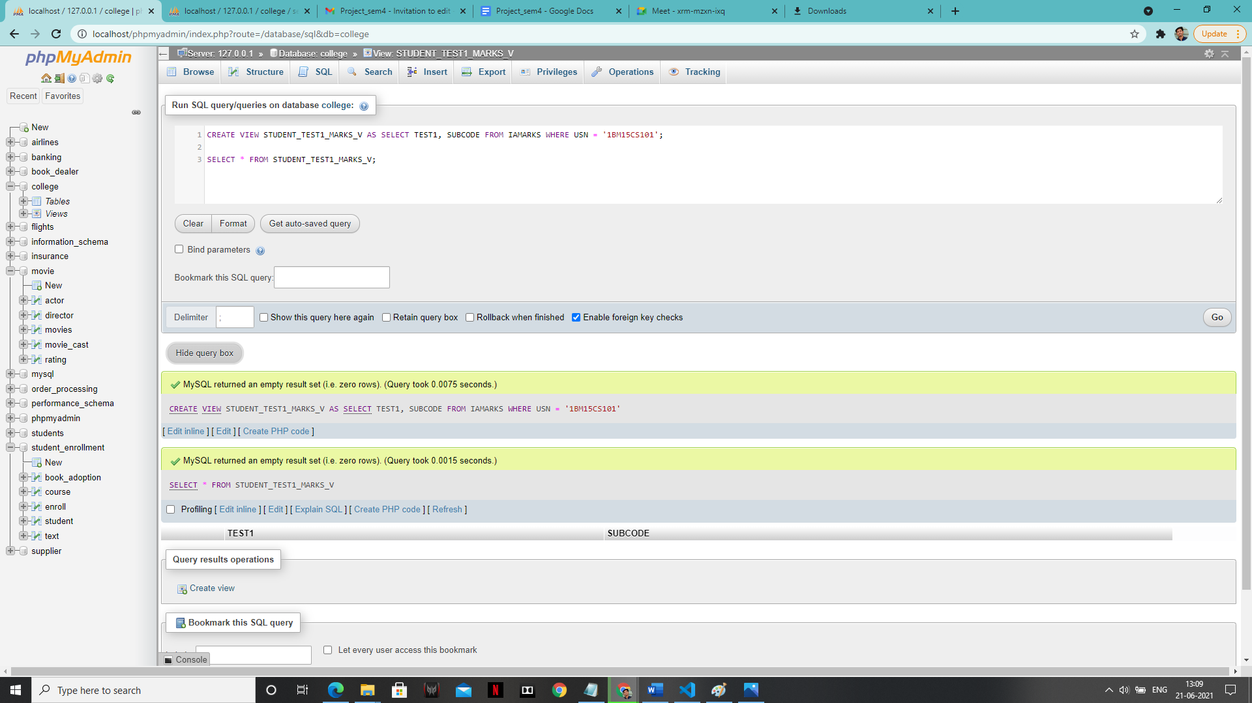

**4:-**

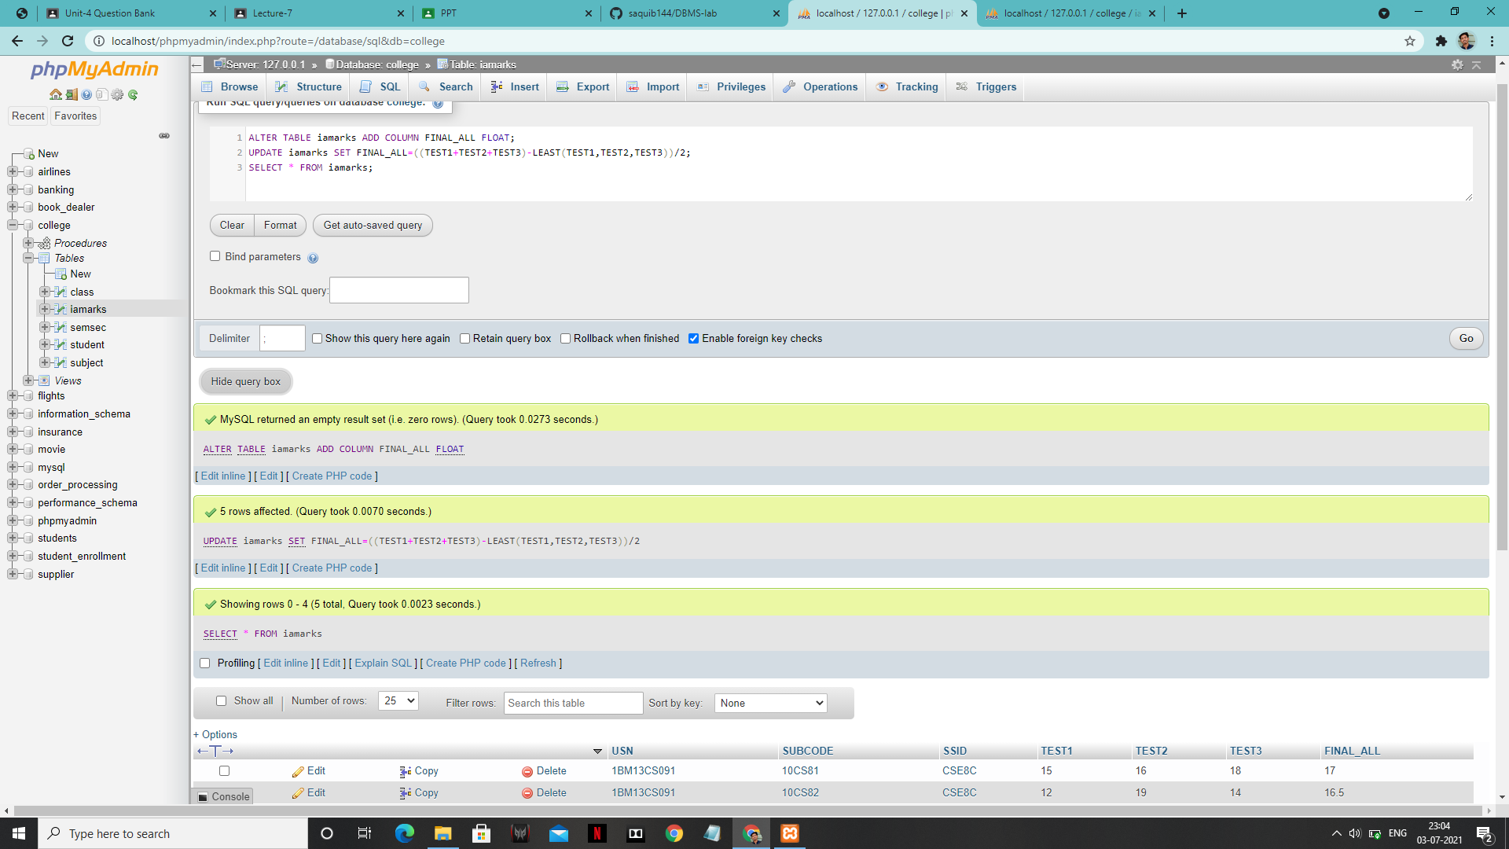

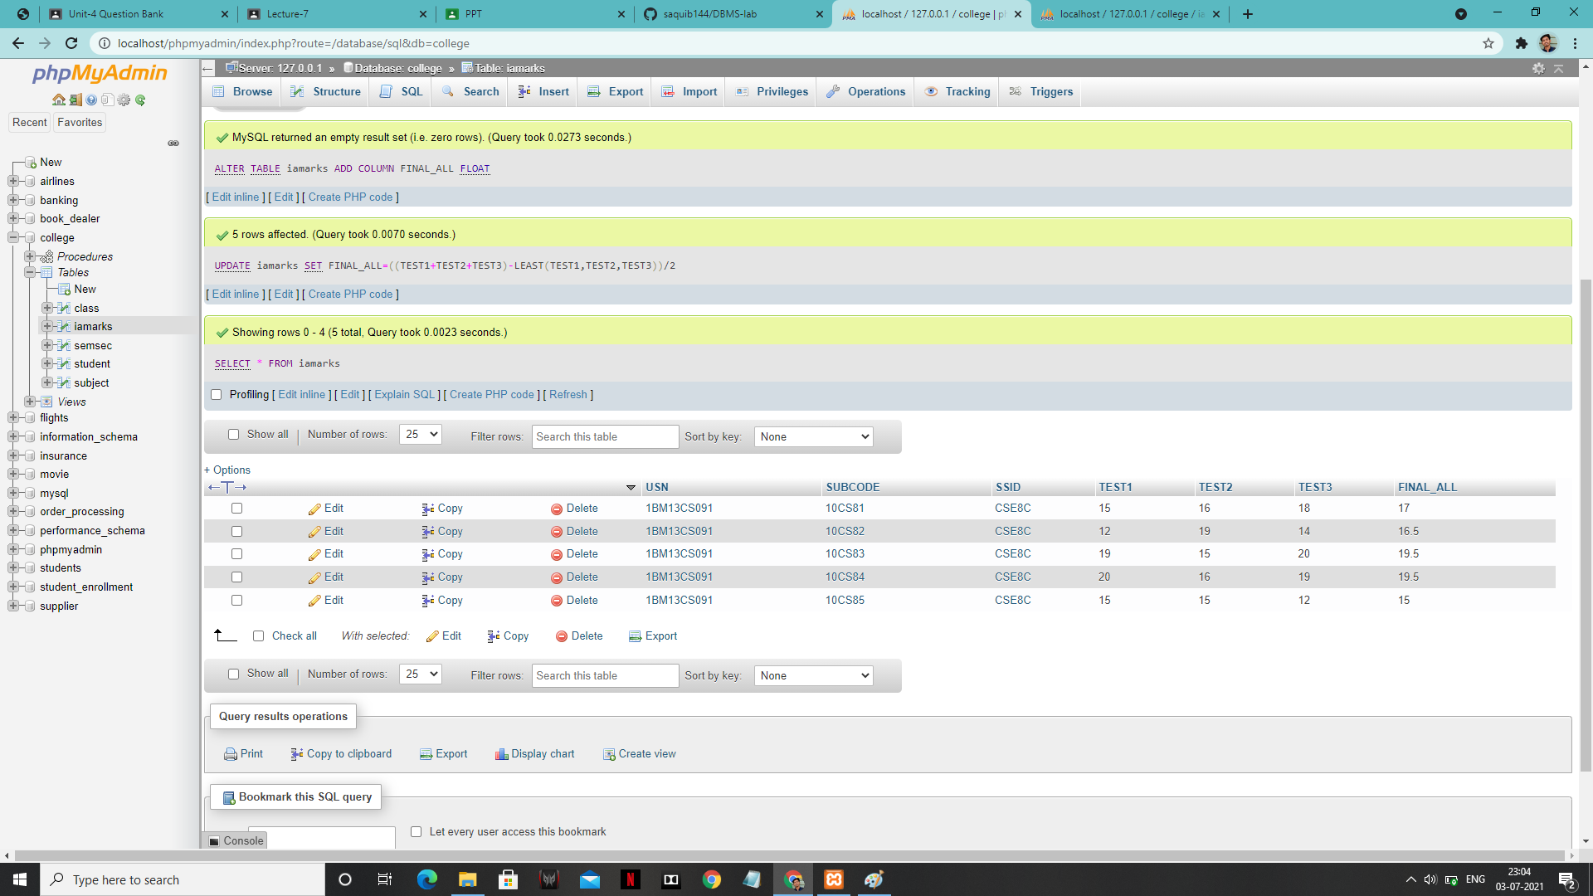

**5:-**



